Setup:
- Ensure vehicle is turned off and parked safely
- Fully open the hood and ensure it is secured
- Locate the ECU in the firewall on the passenger’s side of the vehicle (See Green Arrow)
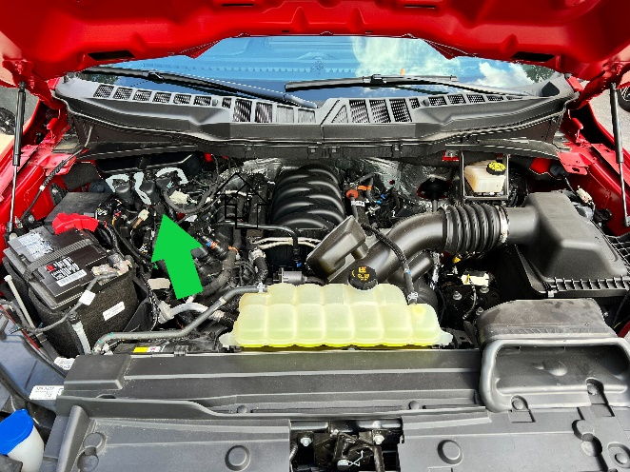

- Disconnect all 3 of the ECU connectors. Be sure to release the locking tab (Green Arrow) before moving gray connector arm.

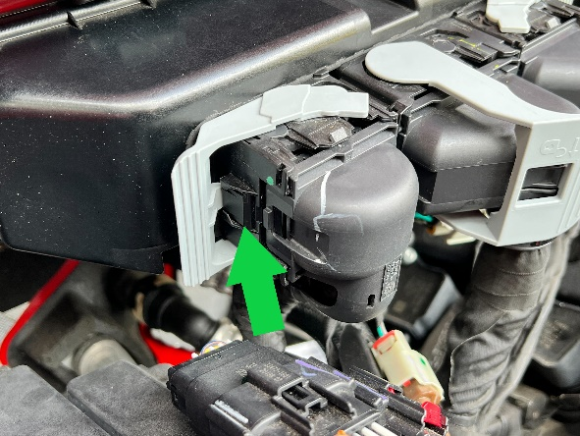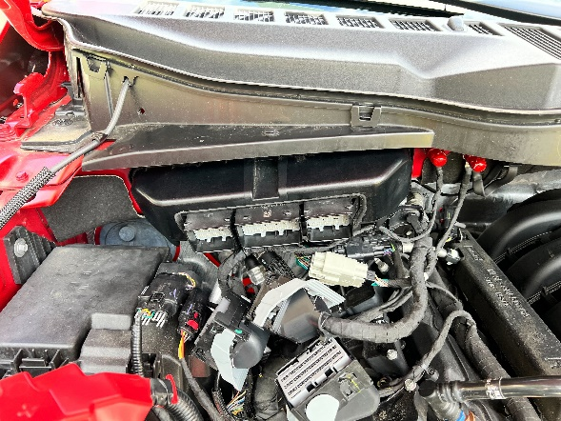

- Connect the ECU connector provided with the X4 to the ECU and to the SCT box
- Connect the X4 to the SCT box using the OBDII cable
- Connect the SCT box to the battery using the battery clamps provided

Tune Install:
- Be sure to have the device setup using the steps above
- On the X4 select Program Vehicle
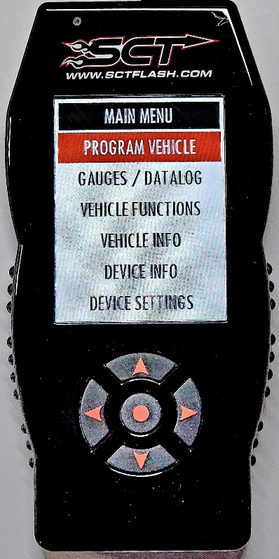
- Review and accept the Street Use Notice
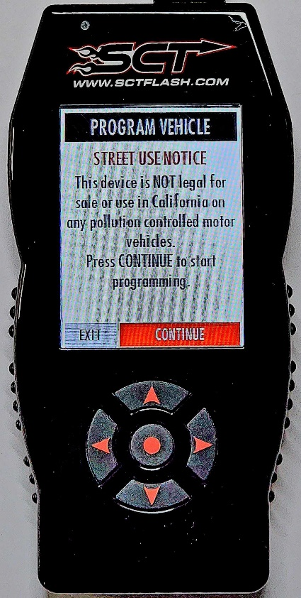
- If this is your first flash, select “Upload Stock”
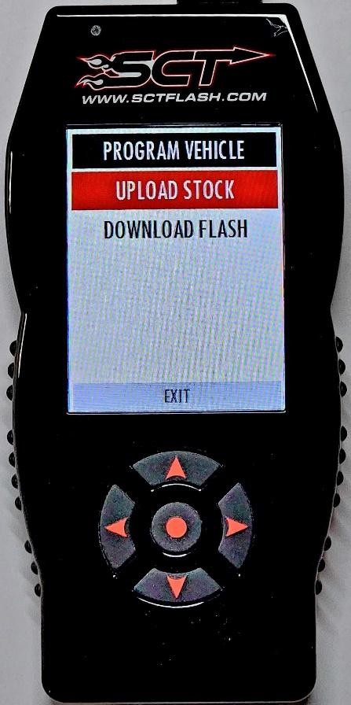
- Once started you will see “Saving Stock Data” run twice. This is normal.
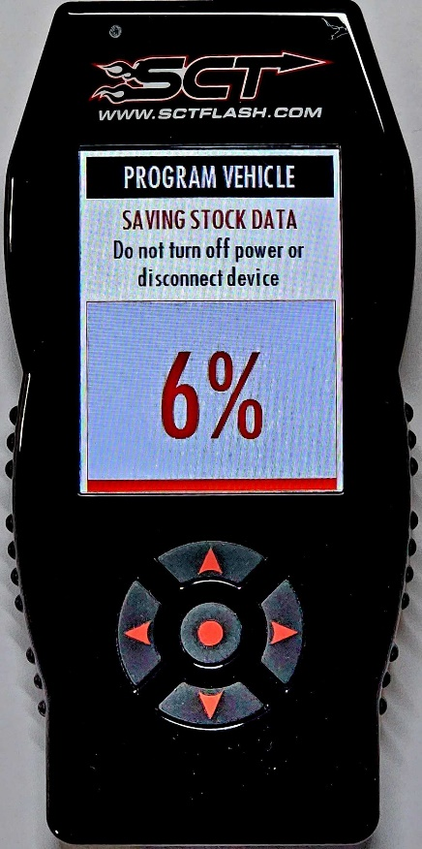
- Once you have uploaded stock select “Download Flash”
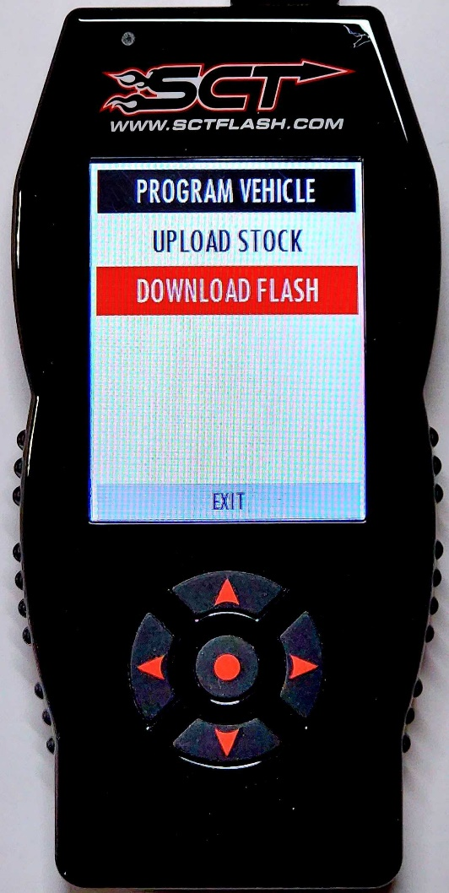
- X4 will now program in the tune file. When complete reconnect the PCM.
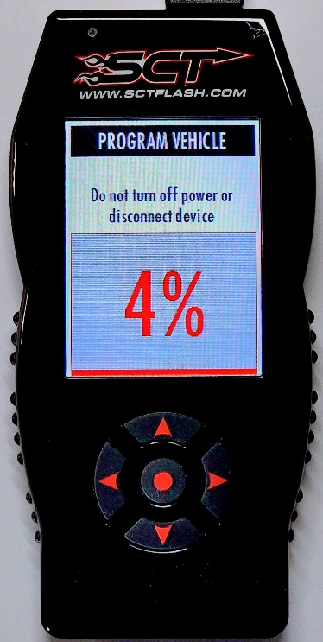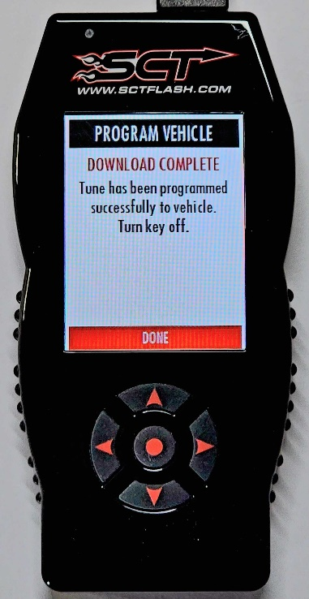

Return to stock:
- Be sure to have the device setup using the steps above
- On the X4 select “Program Vehicle”
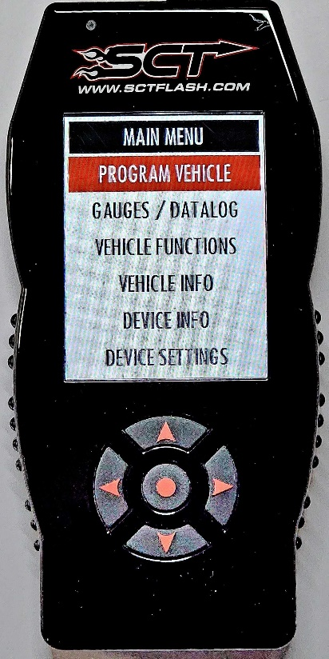
- Review and accept the Street Use Notice
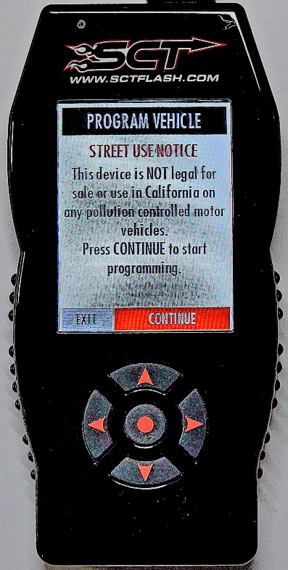
- Select “Return to Stock”
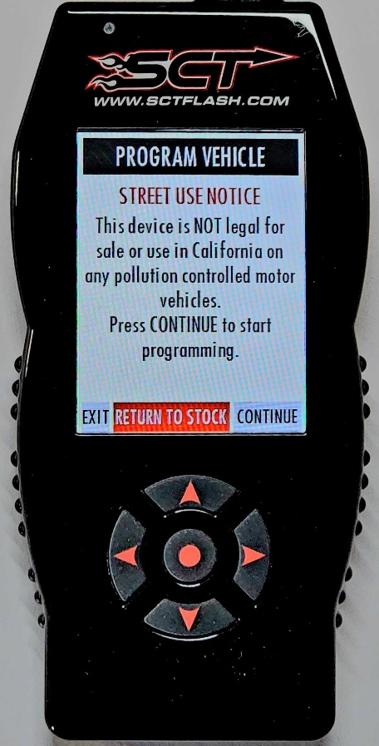
- Confirm Return to Stock
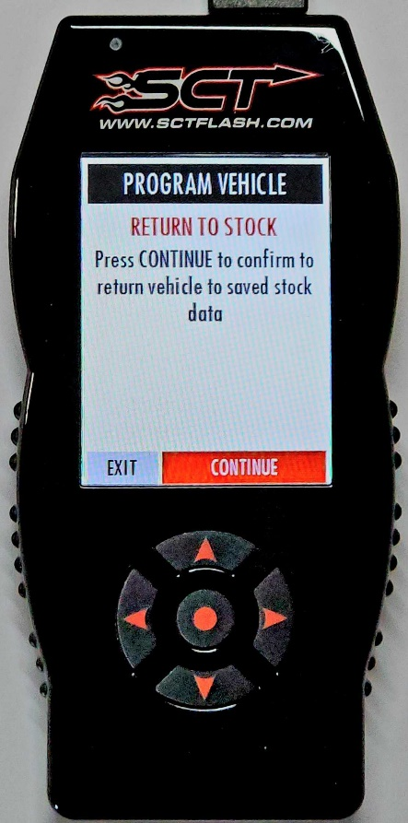
- X4 will now program in the stock file
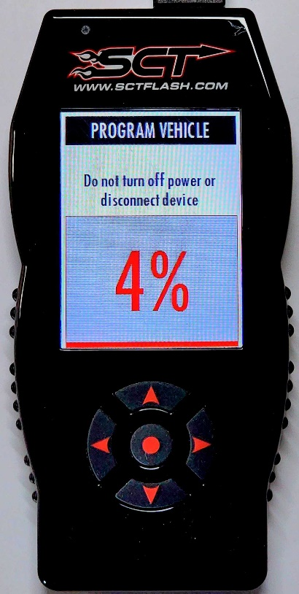
- When complete, reconnect PCM.
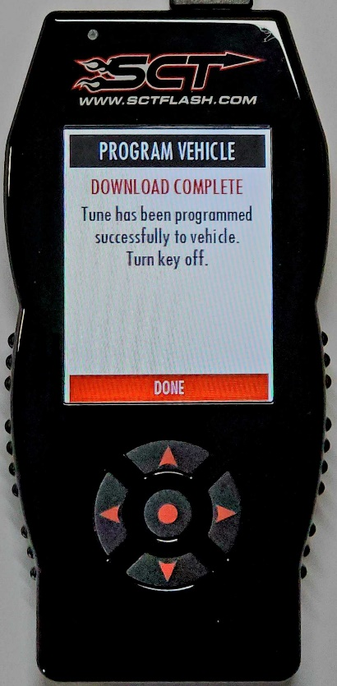

LiveLink Gen-II
- To use LiveLink with the 2021-2022 F150 please update to the current release version including any outstanding database updates.

