Creating and Loading Custom Tunes – GT Platinum

- Before we begin, make sure the GT is up to date by verifying the Software versions within “SHOW SETTINGS” on the GT. If the GT is not up to date, please update via Update Agent.
- After the GT is verified to be up to date, select “MENU” from the start up screen and scroll up to select “CHANGE VEHICLE”. Select the Make/Model/Engine of the vehicle you will be custom tuning.
- Power on the GT by connecting via the OBDII port. Within the “MENU” scroll down to “VEHICLE INFO”, select “VEHICLE INFO”. With the key in the ON position, the serial number and Primary Strategy will auto-populate.
- If the information does not auto-populate, you will need to select “REQUEST STRATEGIES FROM VEHICLE”. The customer will send all of the information that appears on the GT screen to his/her custom tuning dealer to get a custom tune created.

- The strategy may be a part number, VIN, or Engine Strategy.
- LBZ (2006-early 2007), LMM (2007.5-2010) Duramax, and 2007.5+ GM Gas Vehicles require that you select the “EXPORT SUL FILE” option from the Vehicle Info screen. Customer will send the .SUL to the dealer. NOTE: you may only request vehicle strategy if the vehicle is stock. If a Bully Dog preloaded tune is installed on the vehicle you will need to return the vehicle to stock before continuing.
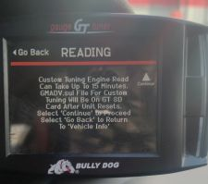
- The .SUL file is labeled as GMADV.SUL. It will be found on the BDCARD in the CUSTOM folder.
